Project Design Phase-II
Data Flow Diagram & User Stories

Date | 25 Sep 2026
Team ID | SWTID-2026-1591
Project Name | AI BlogNest API
Maximum Marks | 4 Marks

Data Flow Diagrams (DFD)
Description:
A Data Flow Diagram (DFD) shows how data moves through the system — where it enters, how it is processed, where it is stored, and where it exits. Our AI BlogNest API has three main external entities: User, ThunderClient (API Client), and Google Gemini AI. Data is stored in MongoDB.
DFD Level 0 (Context Diagram):
External entities:
· User / API Client — Sends HTTP requests (register, login, create blog, summarize).
· Google Gemini AI — Receives content and returns generated/summarized text.

Process:
· 0. AI BlogNest API System — Handles all incoming requests.

Data Stores:
· D1. Users Collection (MongoDB)
· D2. Blogs Collection (MongoDB)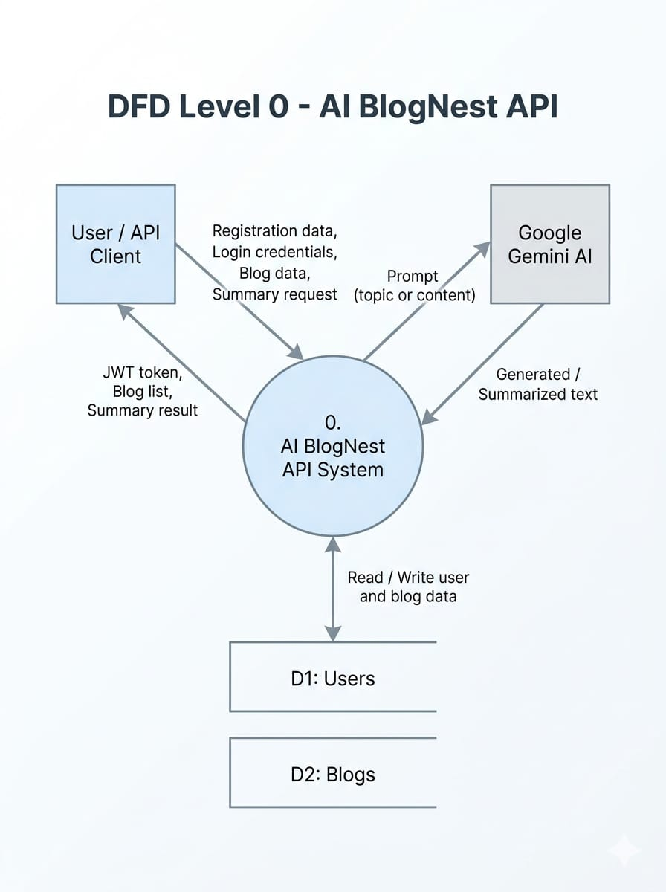

Data Flows:
· User → System: Registration data, Login credentials, Blog data, Summary request
· System → User: JWT token, Blog list, Summary result
· System → Gemini AI: Prompt (topic or content)
· Gemini AI → System: Generated blog / Summary text
· System ↔ Data Stores: Read/Write user and blog data

DFD Level 1 (Detailed):
Processes:
1. 1.0 Authentication — Handles register and login. Reads/writes to Users collection.
2. 2.0 Blog Management — Handles create, read, update, delete of blog posts. Reads/writes to Blogs collection.
3. 3.0 AI Processing — Sends prompts to Google Gemini AI and returns generated/summarized content.
4. 4.0 Middleware Validation — Verifies JWT tokens and user roles before allowing access to processes 2.0 and 3.0.

Data Stores:
· D1. Users
· D2. Blogs

User Stories
Use the below template to list all the user stories for the product.
User Type | Functional Requirement (Epic) | User Story Number | User Story / Task | Acceptance criteria | Priority | Release
Author | Registration | USN-1 | As a user, I can register with my name, email and password | I can create an account and receive a success response | High | Sprint-1
Author | Login | USN-2 | As a user, I can log in with my email and password and receive a JWT token. | I can receive a valid JWt token on successful login | High | Sprint-1
Author | Blog CRUD | USN-3 | As an author, I can create a new blog post | The blog is saved in MongoDB and I get a 201 response. | High | Sprint-2
Reader | Blog CRUD | USN-4 | As a user, I can view all blog posts | I get a list of all blogs with author details | High | Sprint-2
Author | Blog CRUD | USN-5 | As an author, I can update or delete my own blog | Only the original author can modify their post | Medium | Sprint-2
Author | AI Generation | USN-6 | As an author, I can generate a full blog from a topic using Gemini AI | I receive a full blog post generated by AI | High | Sprint-3
Reader | AI Summarization | USN-7 | As a user, I can summarize a long blog into a short abstract using AI. | I receive a concise summary of the content | High | Sprint-3
Admin | Role Management | USN-8 | As an admin, I can manage user roles (Admin, Editor, Author, Reader) | Only admind can change user roles. | Low | Sprint-4
